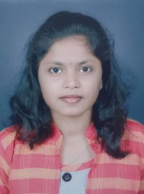**RESUME**

**PRANOTI MAGDUM**

+91 86230 29708

EMAIL ID: [pranotimagdum2000@gmail.com](mailto:pranotimagdum2000@gmail.com)

**OBJECTIVE**

To get an opportunity where I can make the best of my potential and contribute to the organization’s growth.

**EDUCATIONAL QUALIFICATION**

|  |  |  |  |
| --- | --- | --- | --- |
| **Degree** | **University/Board** | **Percentage** | **Year** |
| Bachelor of commerce (advance accountancy) | Shivaji University,kolhapur | 74.60% | 2021 |
| H.S.C | Maharashtra State Board | 74.46% | 2018 |
| S.S.C | Maharashtra State Board | 73.51% | 2016 |

**TECHNICAL SKILLS**

* Basic Computer Knowledge

**WORK EXPERIENCE**

* FRESHER

**SKILLS**

* Time Management
* Sales
* Good Communication Skills
* Positive Attitude

**INTEREST**

* Drawings
* Watching Movies
* Traveling
* Photography

**LANGAUGES KNOWN**

Marathi, Hindi, English

**PERSONAL DETAILS**

Father’s Name : Shri Prakash Madhukar Magdum

Date of birth : 30/04/2000

Address : A/p mangaon, 949,peth lene, near Mahadev temple,

Dist-kolhapur, tal-hatkanangle.

Pin Code : 416 118

Marital Status : Unmarried

Gender : Female

DATE: ………………. Pranoti Prakash Magdum